**Documentation Manual for**

**the Apache HTTP Server**

**9325B - G4**

Arellano, Henry

Dacapias, Princess Lyka

Edades, Bryn

Pocaan, Dominic

Titiwa, Karen Ivy

Wille, Renz

Date

Table of Contents

**INTRODUCTION**

Websites like Facebook and Google, which are accessible via the Internet, are hosted in servers like physical, virtual and dedicated servers. These servers have an actual physical hardware (like external hard drives) where the picture you posted on Facebook are stored.

The hardware with the help of a server program sends you back the login/sign up page of Facebook whenever you enter <https://www.facebook.com> on any browser. Basically, what happens is that the client(you) sends a request to the server by entering <https://google.com> in a browser and what the server does is to provide you the search engine of Google. It is also the case when you ask Google for the answer to your homework.

In relation to this, the Apache Software Foundation has created an Apache HTTP Server which you can use to host your own website. In hosting websites, virtual hosts are usually used to minimize cost and to maximize the capabilities of servers.

Servers before can only host one website but, with virtual hosts, it is now possible to host two or more websites on a single machine. Virtual hosting can be achieved in two ways : IP-based(different IP addresses for every website) or name-based (different names running on the same IP address).

In this manual, we will make use of the “name-based” virtual hosting. (see Apache documentation for IP-based approach).

**Objective**

1. Create virtual hosts that are mapped to the following domain names (www.group4a.org, www.group4b.org, and [www.group4c.org](http://www.group4c.org).)
   1. Use the contents of the group’s advocacy and awareness websites as contents for the virtual hosts established for the Apache HTTP Server.
   2. Check that the virtual hosts are accessible from a browser of the host machine (add the necessary entries into the hosts file of the host machine).

**Prerequisites**

* You need an Ubuntu server installed with apache2
* Basic knowledge in file manipulation using Ubuntu

To create a virtual host, first, go to sites-available and copy 000-default.conf

cd /etc/apache2/sites-available

sudo cp 000-default.conf group4a.org.conf

Open the newly created virtual host

sudo vi group4a.org.conf

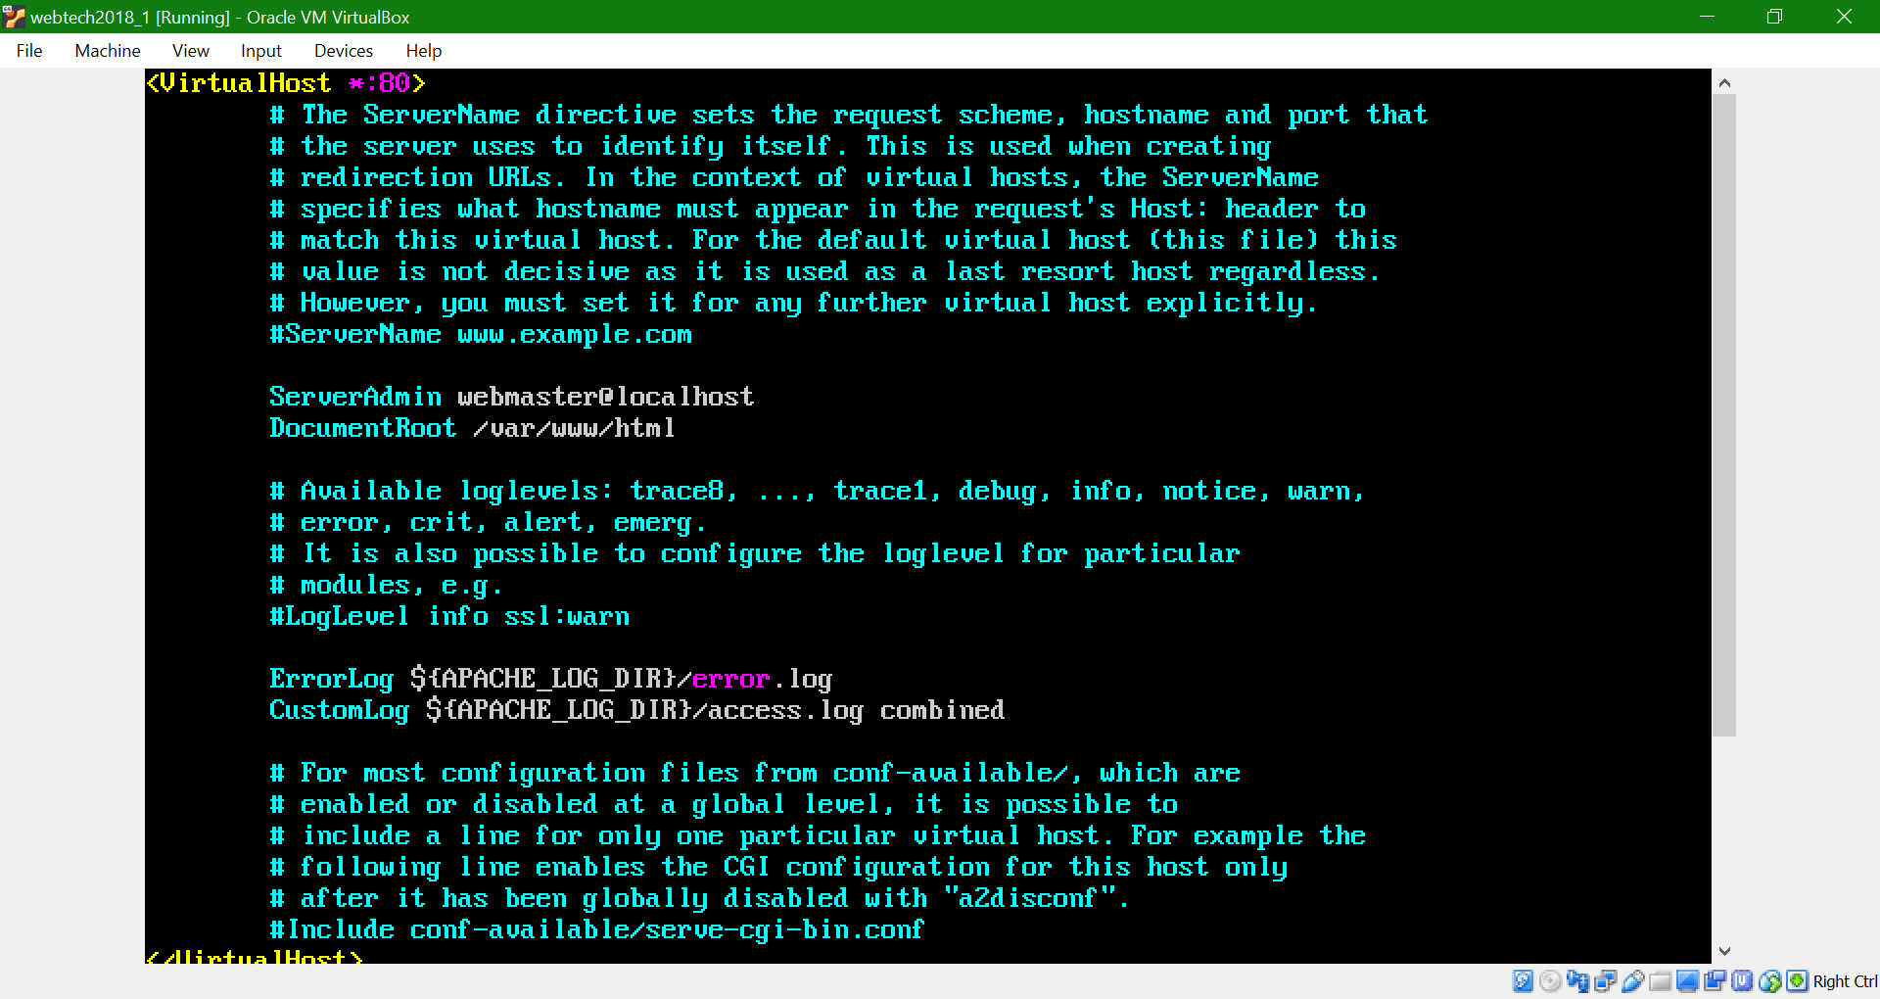

The basic necessary elements in creating virtual hosts are the (1) VirtualHost block, (2) ServerName and (3) DocumentRoot. All string preceded by ‘#’ are comments.

Uncomment the “ServerName” and beside it, enter the server name or the domain name of your website. The value of the ServerAlias is another name for the ServerName, meaning, group4a.org can also be used to browse [www.group4a.org](http://www.group4a.org). The DocumentRoot points to the directory where the contents of group4a.org resides.

*Note : ServerAlias may be omitted in creating virtual hosts.*

*Remember the directory you specified for the DocumentRoot as it will be used later.*

*To edit the file, press i.*

*To save the file press, Esc and then enter “:wq”*

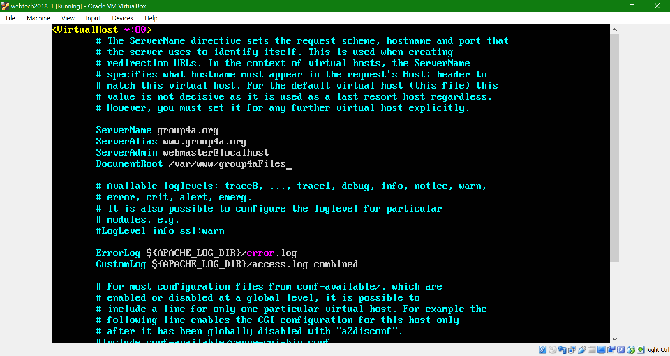

If you want to create anoter virtual host, following the same steps you did earlier.

sudo cp 000-default.conf group4b.org.conf

sudo vi group4b.org.conf

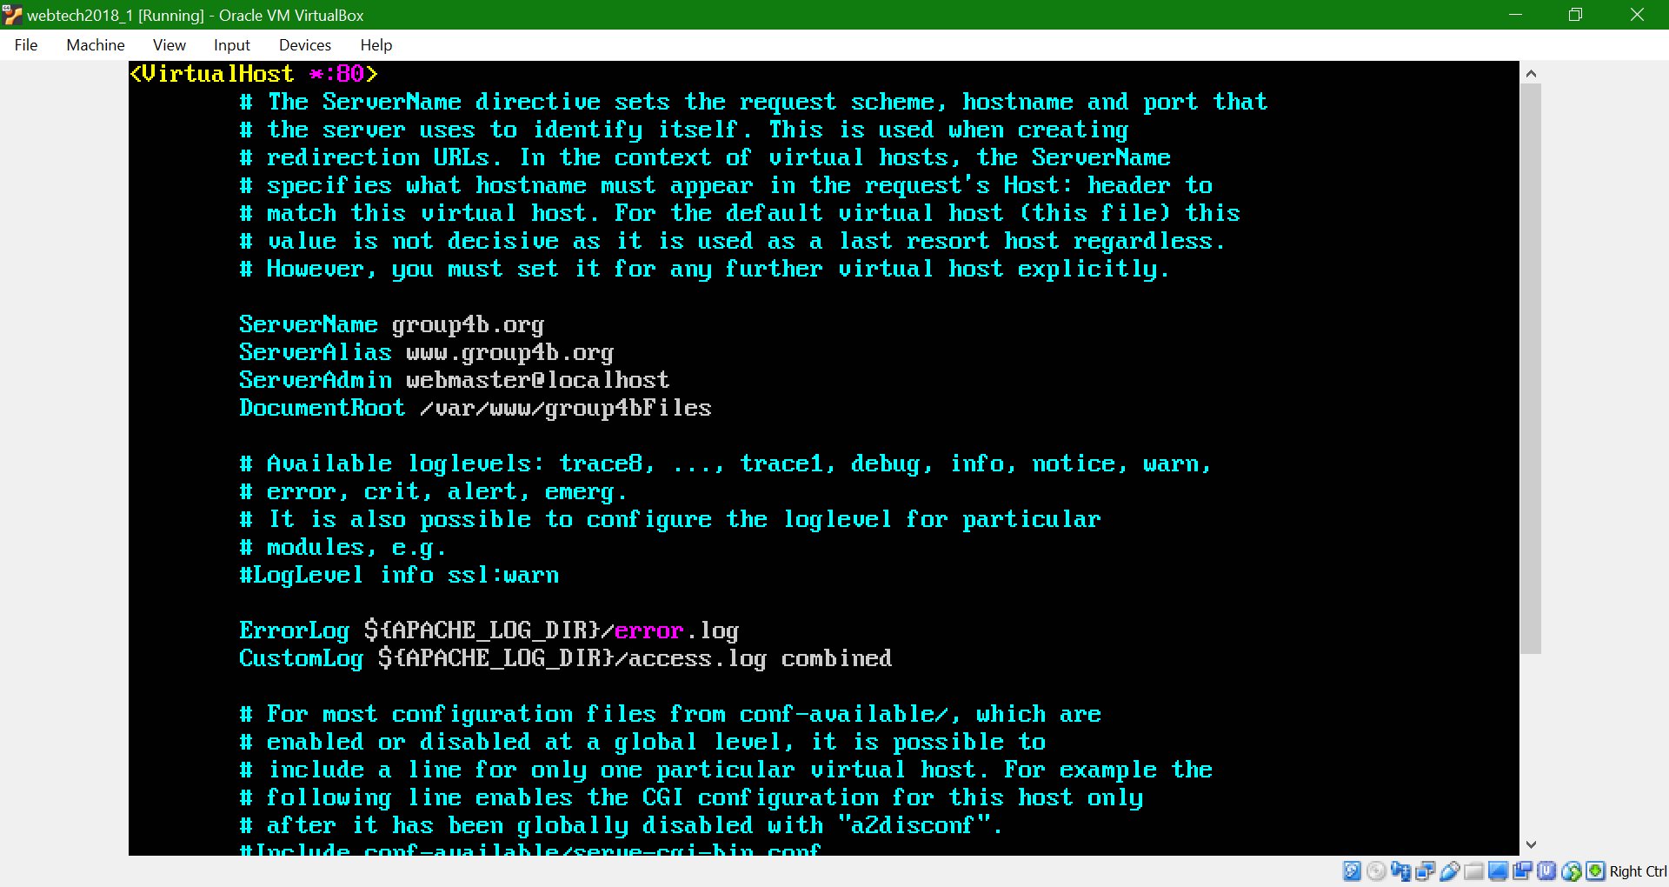

Here’s another virtual host.

sudo cp 000-default.conf group4c.org.conf

sudo vi group4c.org.conf

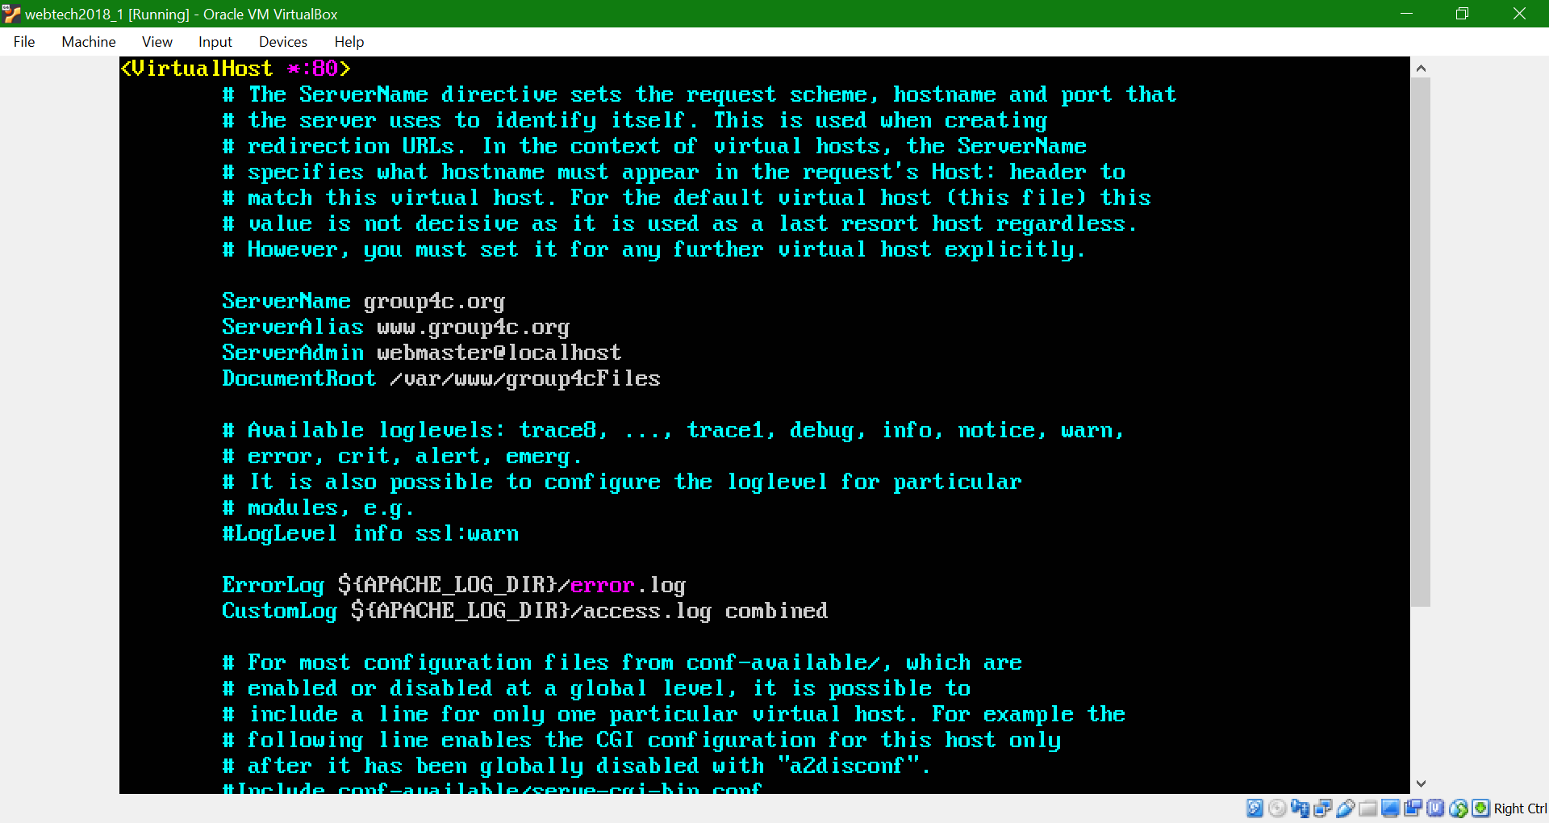

After creating the virtual hosts, you are going to create folders where you’re going to store your html files, css files and proabably images.

cd

cd /var/www

Earlier , the following values(bold string) for the three different virtual hosts were used;

DocumentRoot /var/www/**group4aFiles**

DocumentRoot /var/www/**group4bFiles**

DocumentRoot /var/www/**group4cFiles**

To create folders for the three different websites using the filenames you used in the DocumentRoot

sudo mkdir group4aFiles

sudo mkdir group4bFiles

sudo mkdir group4cFiles

ls

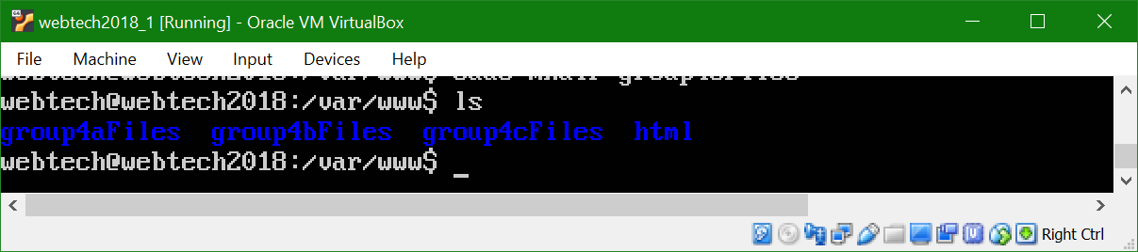

If you have a repository in GitHub or in GitLab, you can copy the URL and clone the url in the repository

**GitHub**

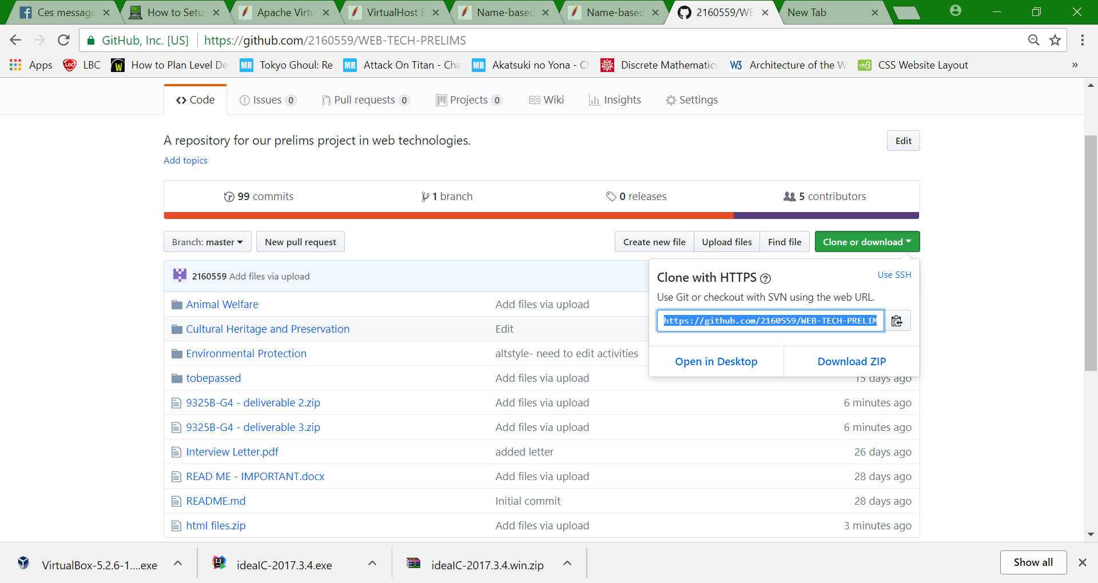

**GitLab**



sudo git clone <https://github.com/2160559/WEB-TECH-PRELIMS.git>

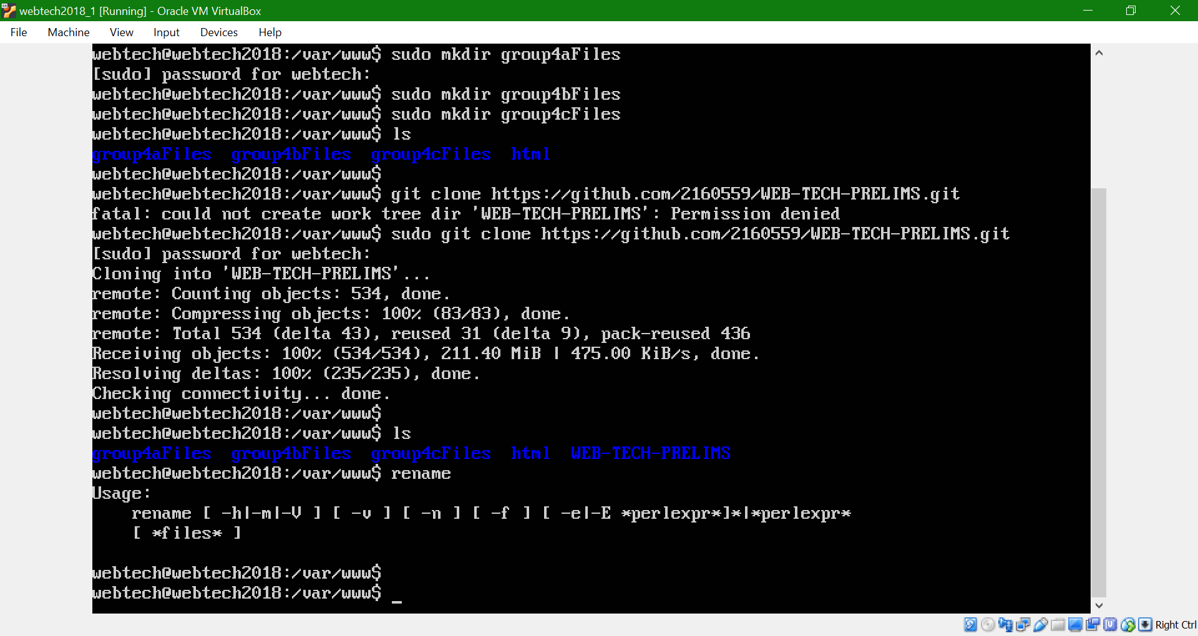

Organize your files

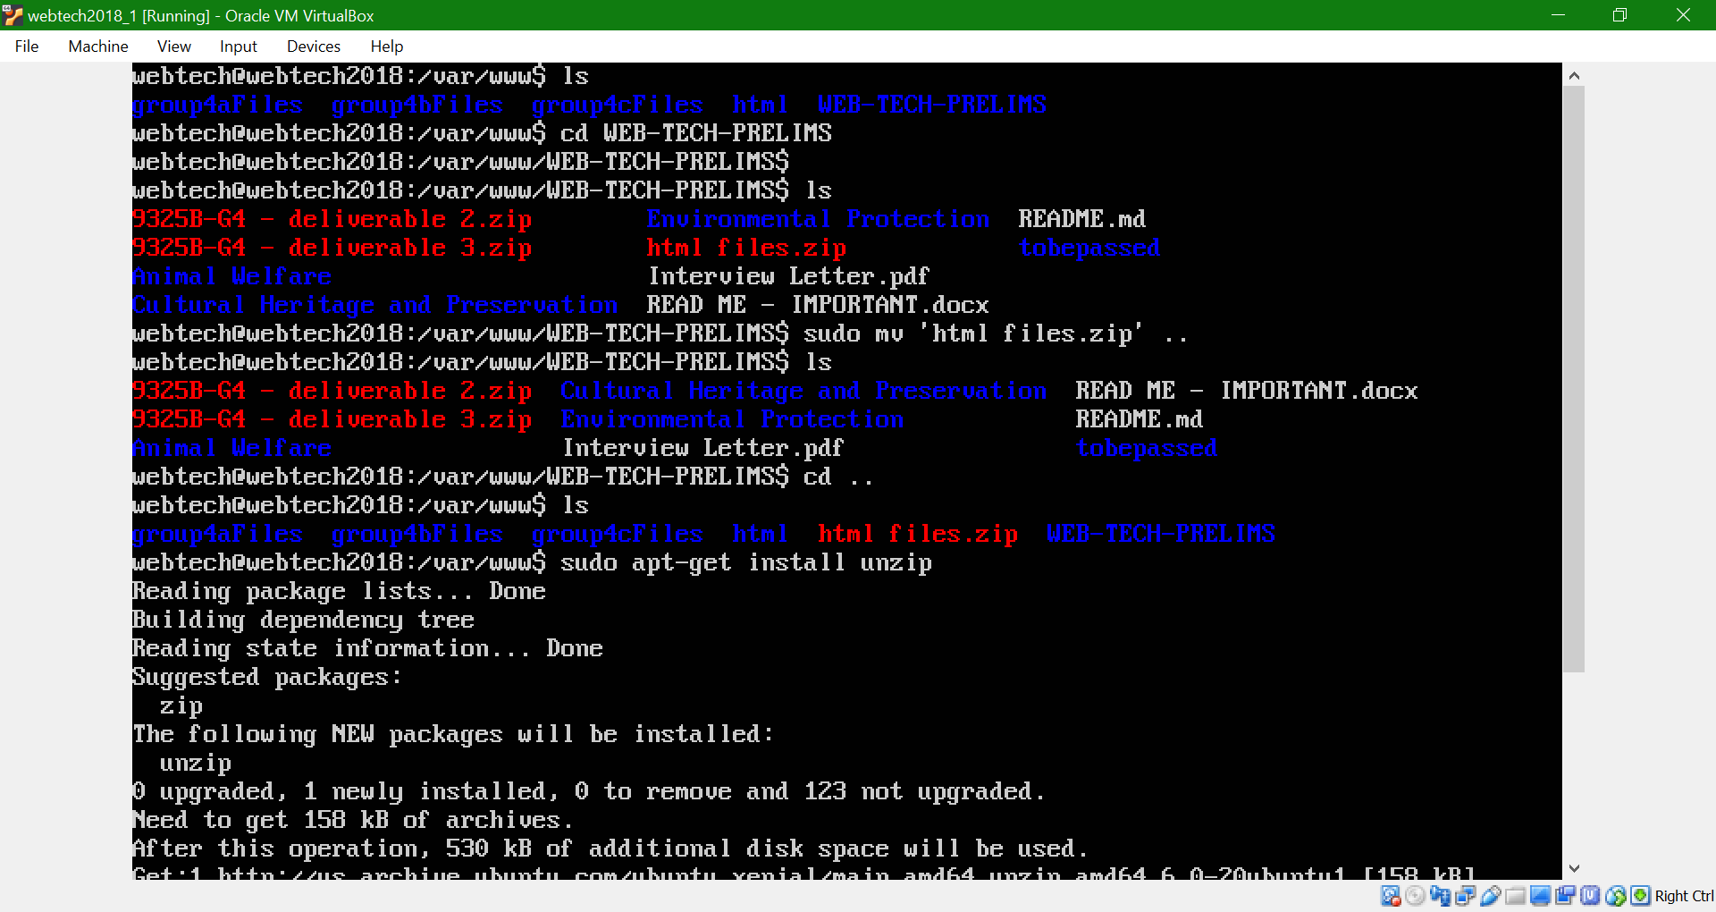

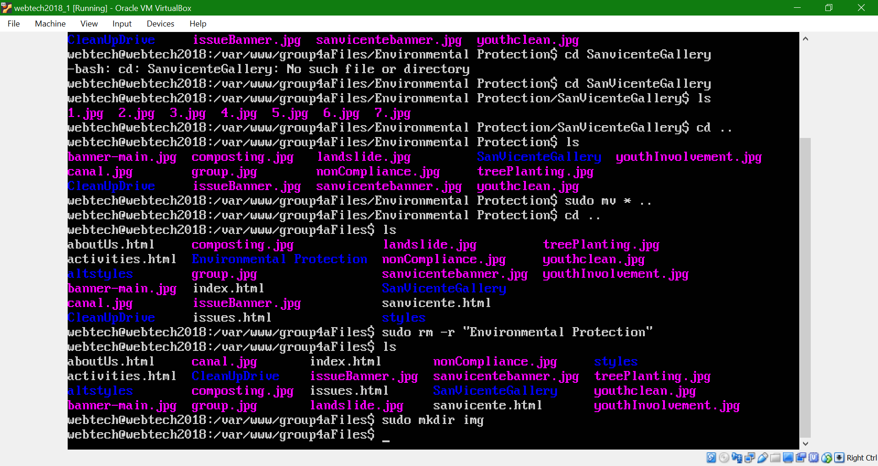

You can delete the html directory if you have nothing to you is for.

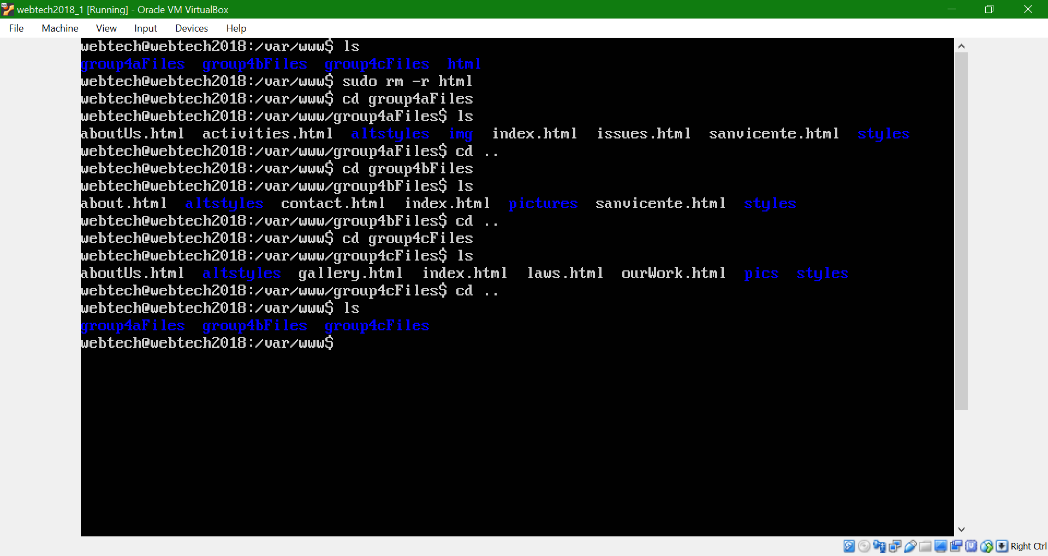

After organizing your files, enable the virtual hosts

Sudo a2ensite group4a.org.conf

Sudo a2ensite group4b.org.conf

Sudo a2ensite group4c.org.conf

If you were asked to run ‘service apache2 reload’, then do so.

Service apache2 reload

Restart apache for changes to take effect

sudo service apache2 restart

Go to the hosts file [C:\Windows\System32\drivers\etc\hosts ] and add the following:

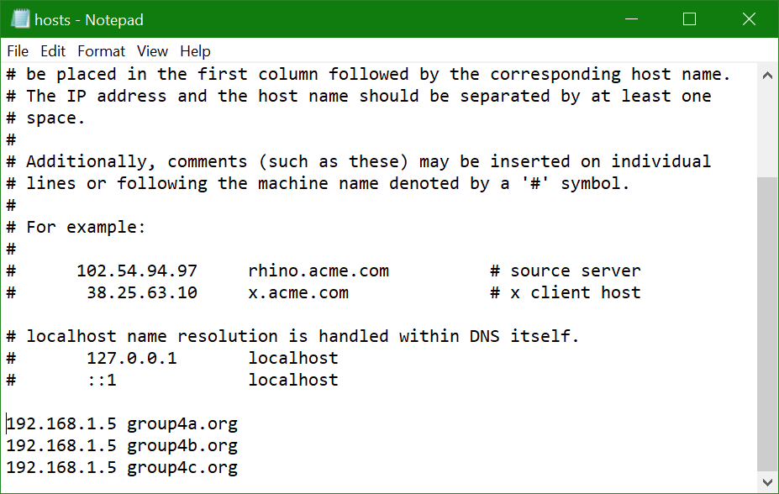

Finally, go to your favorite web browser and enter the domain name of your website.

